MOBILE COMPUTING

UNIT 1 WIRELESS COMMUNICATION FUNDAMENTALS

Topics to be covered:
1.Introduction , 2. Wireless transmission , 3. Frequencies for radio transmission, 4. Signals,
5. Antennas, 6. Signal Propagation, 7. Multiplexing, 8. Modulations, 9. Spread spectrum,
10. MAC – SDMA – FDMA – TDMA – CDMA , 11. Cellular Wireless Networks.

1.Introduction

Mobile computing is a form of human–computer interaction by which a computer is expected to be transported during normal usage. Mobile computing has three aspects: mobile communication, mobile hardware, and mobile software. The first aspect addresses communication issues in ad-hoc and infrastructure networks as well as communication properties, protocols, data formats and concrete technologies. The second aspect is on the hardware, e.g., mobile devices or device components. The third aspect deals with the characteristics and requirements of mobile applications.

Mobile computing systems have different constraints and hence different solutions. Main challenges are due to
- Wireless - Unreliable.
- Mobility - Dynamism of information.
- Portability - Limited resource

2. Wireless

In earlier days the way of accessing the network was by wire. But, now the wires are replaced by electromagnetic waves through the air.

A communication device can have one of the following characteristics:

- Fixed and Wired: Desktop uses fixed Networks.
- Mobile and Wired: Laptop connected using Telephone and Modem.
- Fixed a Wireless: This mode is used for installing network in historical buildings to
avoid damage caused due to wiring.
- Mobile and Wireless: No cable and the users can roam.

2.2 Principles of Mobile Communication

It is based on electro-magnetic radio transmission.
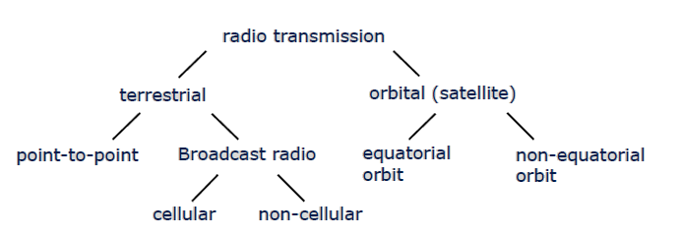

Principles:
- Propagation and reception of electro-magnetic waves.
- Modulation and multiplex methods.
- Focusing on cellular networks.

2.3 An overview of Mobility and Portability

Mobility

Mobility is the state of being in motion. There are two kinds of mobility.

- User mobility: Refers to a user who has access to the same telecommunication services at different places. Users can communicate (wireless) “anytime, anywhere, with anyone”. Users are mobile and the services also follows (e.g.,) call forwarding in Telephones.

- Device portability: Refers to the movement of communication devices. Devices can be connected anytime, anywhere to the network. (e.g.,) mobile phones.

Issues for Mobility:

- Bandwidth restrictions and variability
- Location-aware network operation
        - User may wake up in a new environment
        - Dynamic replication of data
- Querying wireless data & location-based responses
- Busy network activity during connections & handling disconnections

Issues for Portability:

    - Battery power restrictions
    - Risks to data
  - Physical damage, loss, theft
  - Unauthorized access
  - Encrypt data stored on mobiles
  - Backup critical data to fixed (reliable) hosts
    - Small user interface
  - Small displays due to battery power and aspect ratio constraints
  - Cannot open too many windows
  - Difficult to click on miniature icons

2.4 Applications

- Vehicles
  - Transmission of news, road condition, weather, music via DAB
  - Personal communication using GSM
  - Position via GPS
  - Local ad-hoc network with vehicles close-by to prevent accidents, guidance system, redundancy
  - Vehicle data (e.g., from busses, high-speed trains) can be transmitted in advance for maintenance

- Emergencies
  - Early transmission of patient data to the hospital, current status, first diagnosis
  - Replacement of a fixed infrastructure in case of earthquakes, hurricanes, fire etc.

- Travelling salesmen
  - Direct access to customer files stored in a central location
  - Consistent databases for all agents
  - Mobile office

- Replacement of fixed networks
  - Remote sensors, e.g., weather, earth activities
  - Flexibility for trade shows
  - LANs in historic buildings

- Entertainment, Education,
  - Outdoor Internet access
  - Intelligent travel guide with up-to-date location dependent information
  - Ad-hoc networks for multi user games

Location dependent services

- Location aware services
  - Services exist in the local environment. e.g., printer, fax, phone, server etc.

- Follow-on services
  - Automatic call-forwarding, transmission of the actual workspace to the current location

- Information services
  - Push: e.g., current special offers in the supermarket
  - Pull: e.g., where is the Black Forrest Cherry Cake?

- Support services
  - Caches, intermediate results, state information etc. „follow“ the mobile device through the fixed network Privacy
  - Who should gain knowledge about the location

2.5 Mobile and Wireless Devices Examples

- Sensor: switch Sensing Office Door.
- Embedded Controller: TV ,Washing Machine
- Pager: Receiver, Displays short text message.
- Mobile phones
- PDA: Personal Digital Assistant,
- Pocket Computer,
- E-Notebook
- Laptop

2.6 Reference Model

The reference model of wireless system is as follows,
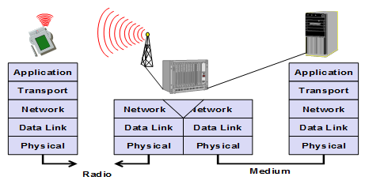

Functions of the layers in Wireless and Mobile Environment

Wireless transmission Systems offers data transport services to higher layers.

- Physical Layer

- The lowest layer in the communication system. This layer is responsible for conversion of bits into signals that can be transmitted in the sender side. The physical layer of the receiver then transforms the signals back into bit stream. It is also responsible for frequency selection, generation of carrier frequency, signal detection, modulation and encryption.

- Data Link layer

- The function is to access the medium and multiplex the data streams.
- Correction of transmission errors and synchronization.
- It is responsible for reliable point to point connection between two devices or point to multipoint connection between one sender and many receivers.

- Network Layer

- The function is routing of packets through network .The other functions are addressing, device location and handover between different networks.
- Transport layer

- This layer is used to establish an end to end connection
- The other functions are QoS, flow and congestion control.

- Application layer

- The top most layers. The functions are service location, support for multimedia application, latency, etc.,

3. Frequencies for Radio Transmission

The medium is wireless and the transmission is done via different radio frequency bands. The frequency and wavelength is related as follows,
λ= c/ƒ
Where, c is the speed of light 3 x 10⁸ m/s, f is the frequency.
Ranges:

The radio frequency is a spectrum and it is divided into different frequency bands as follows,

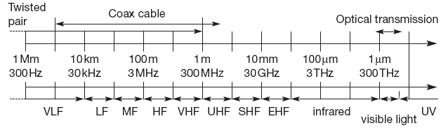

Applications of different ranges:

- VLF –Very Low Frequency – used in submarines
- LF-Low Frequency Range (30 kHz to 300 kHz)-used in submarines.
- MF – Medium Frequency Range (300 kHz to 3 MHz)-used in Radio Stations..
- HF – High Frequency Range (3 MHz to 30 MHz)-used in TV Stations.
- VHF – Very high Frequency (30 MHz to 300 MHz)-used in DVB.
- UHF – Ultra High Frequency (300 MHz to 3 GHz) - Mobile.
- MW – Micro Wave Frequency (>3 GHz).

4.Signals

Signals are the physical representation of data. Data is converted into signals in physical layer. Communication between the systems can be done through transmission of signals. Signals are functions of time and location.

Classification of signals:

    - Continuous time/discrete time
    - Continuous values/discrete values
    - Analog signal = continuous time and continuous values
    - Digital signal = discrete time and discrete values

The signal for radio transmission is the periodic signal that too sine waves as carriers.
Function of a sine wave is
g (t) = A_{t} sine (2Πƒ_{t} + Ψ_{t} )

Parameters are

- Amplitude A - Amplitude of the signal
- Frequency ƒ - Periodicity of signal.
- Phase Shift Ψ - determines the shift of the signal relative to the same signal without a shift
- t is time

Wave Form Representation: The signals are represented by waveforms as shown below.
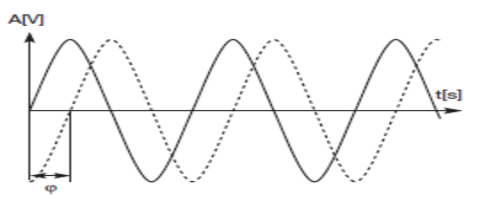

g (t) = instantaneous value of the sine wave signal.
A_{t} = maximum amplitude of the sing wave signal.
ƒ _{t}= Frequency f the periodic sine wave signal.
t = time
Ψ = phase shift.

In the above representation the problem is that if the signals contain many different frequencies.

The other ways to represent the signals are ,
- Frequency domain,
- Phase domain.

- Frequency domain:
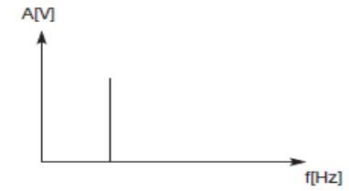
- Phase Domain:

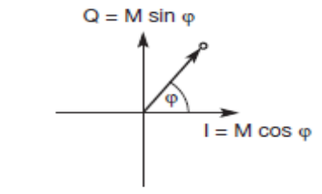

This representation is also called as phase state or signal constellation. X-axis is called in Phase 1 and Y –axis is called Quadrature. Y-axis is phase shift of 90⁰.

5. Antennas

In wireless there are no wires and signals are transmitted through space. But the energy from the transmitter to the outside needs to be coupled. This is the function done by the antenna. Antenna couples the energy to and from spaces and to and from other conductor. It couples the electromagnetic waves. It transmits and receives the data using transmitter and receiver.

Types of Antenna

- Isotropic Radiation (Theoretical antenna):

The reference antenna model1 is isotropic radiator. The concept is that it radiates equal power in all direction.(i.e.,) radiation pattern is symmetric. This does not exist in reality.

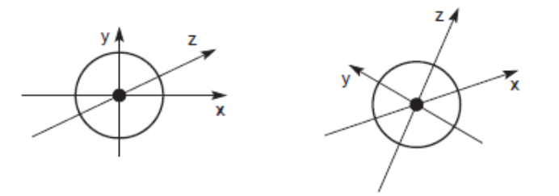
- Dipole (Real antenna):

This is the real antenna. Which follows the directive effects (i.e.) intensity of radiation is not same in all directions. This is also called as Hertzian dipole.
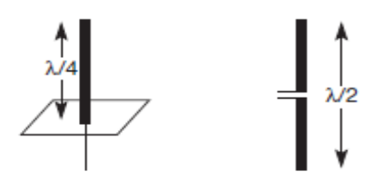

Simple Antenna

Construction of Dipole:

It has 2 collinear conductors of equal length, separated small gap. This gap is called as feeding gap. The length of the dipole is not arbitrary. The length of the dipoles is λ/2, where λ is wavelength of signal. λ/2 dipole has a uniform radiation in on plane which is Omni directional.

Radiation Pattern of Dipole:

It is used for the measurement of radiation around an antenna
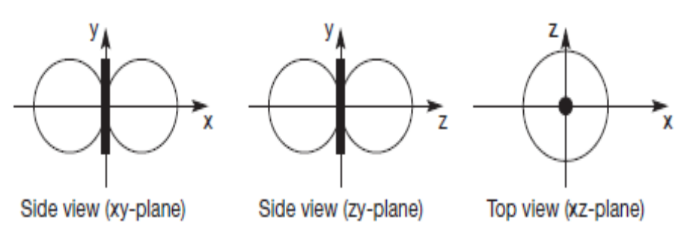
Directed Antenna:

If an antenna is positioned, e.g., in a valley or between buildings, an omni directional radiation pattern is not very useful. In this case, directional antennas with certain fixed preferential transmission and reception directions can be used.
Directed antenna is combined to form sectorized antenna. This helps in frequency reuse. It is often used for microwave connections or base stations for mobile phones (e.g., radio coverage of a valley)
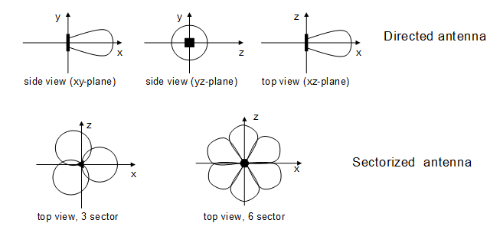

6. Signal propagation

Wireless communication networks need senders and receivers of signals. As the wireless do not have wires hence direction of propagation is difficult to determine. The strength of signal is different at different point. The determination of the behavior of the signal is predictable only in vacuum
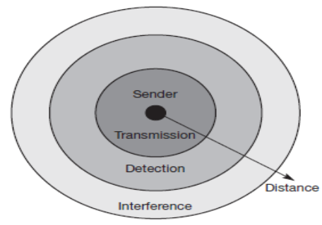
Range of transmission

The above figure shows that the strength of the signal depends upon other factors. Propagation in free space is always like a light (travels in straight line).
Receiving power is proportional to 1/d² (d = distance between sender and receiver)

Receiving power additionally influenced by
      - Fading (frequency dependent)
      - Shadowing
      - Reflection at large obstacles
      - Scattering at small obstacles
      - Diffraction at edges

1. Transmission Range:
Within the certain radius of the sender the receiver can receive the signals with low error and the receiver can communicate back to the sender.

2. Detection Range:
Within the next radius, detection of the signal is possible. Since, the signal is transmitted with large amount of power to distinguish it from back ground noise.

3. Interference Region:
Within the third radius the sender interferes with other transmission by adding noise. The receiver cannot detect the signals and the signals disturb other signals.

The Problems of Wireless Signals
  - Path loss of radio signals
  - Propagation effects on signals
  - Multipath propagation

- Path loss of Radio Signals
In free space the radio signals propagate as light and follow a straight line. When the straight line exists between sender and receiver it is called as line of sight (LOS). Even in vacuum the signal suffers from free space loss. The received power in vacuum depends on,
    - Distance between the sender and receiver , pα (1/d²).
    - Wavelength and gain of receiver and transmitter antennas.
In real scenario the power depends upon the atmospheric conditions. When the distance is short then the path loss (or) attenuation is negligible. The propagation behavior of the radio waves is,

1.Ground wave: (<2 MHz) these are the waves with
- Low frequency
- Follow the earth surface
- Can travel long distances.

2.Sky Wave: (2-30MHz)
- The waves are reflected at ionosphere.
- The waves bounce to and from the ionosphere and earth.
- Travels around world.

3. Line of signal: (>30MHz)
- The waves follow a line of sight.
- Hence there can be a direct communication with satellites.
- In the atmosphere they suffer from refraction.

- Propagation Effects on Signals
As there is the atmosphere between the sender and the receiver the radio waves do not follow line of sight. The effects caused due to the distance between the sender and receiver on the radio signals are,

1.Blocking (or) Shadowing:
- This is the extreme form of attenuation.
- Even small obstacles block the signal.

2.Reflection of Signals:
- When the object is large, when compared to the wavelength of the signal, the signal is reflected. The strength of the signal decreases.

3. Refraction:
- The velocity of the electromagnetic waves depends upon the density of the medium.

4.Scattering:
- If the size of the obstacle is lesser than the wavelength the waves are scattered.

5.Diffraction:
- Diffraction is similar to to scattering. The radio waves will be deflected at an edge and propagate in different directions.

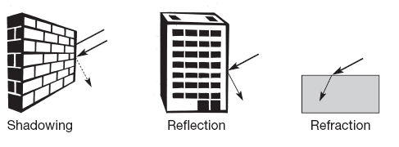
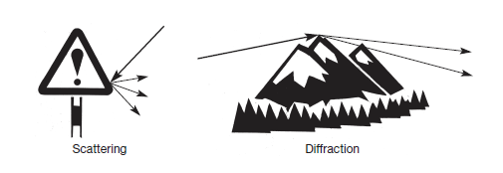

- Multipath Propagation

The propagation effects leads to channel impairment called multipath propagation. In
the following figure the sender is at left and receiver is in the car and 3 paths the signal takes.

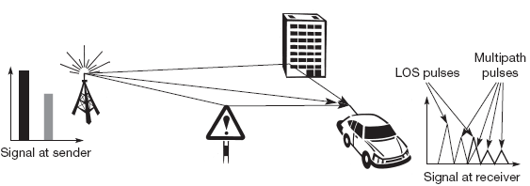

Radio waves emitted by the sender can travel along a straight line or reflected or scattered. The real situation is that the signals can take many paths. At the receiver, due to the different paths with different length the signals reach the destination at different times. This is called as delay spread.

Effects of Delay Spread:

- The short impulse will be smeared on to a broader impulse (or) to weaker impulse. Consider
the above figure.

- There are 3 possible paths; hence the receiver receives 3 smaller impulses.
- Each path has a different attenuation and pulse have different power.
- Some of the pulses will be very weak to be detected. Consider the second impulse on the sender.

They are separated from each other. Consider the second impulse on the receivers.

- The shaded part represent that the signals are overlapped. As we know the impulse represents a symbol which in turn represent a bit. The energy intended for one symbol spills over to the adjacent symbol leading to an effect called inter symbol interference (ISI) (i.e.) the overlapping area. This overlapping leads to misinterpretation of symbols, hence causing transmission errors.

The original signal is spread due to different delay on the parts of signals.

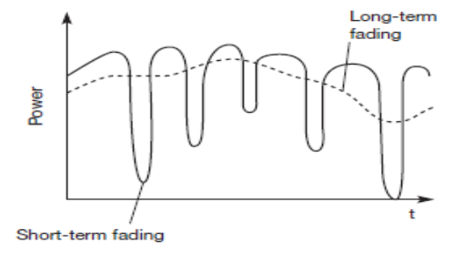
Original signal propogation

To avoid this overlapping the receiver should know the channel characteristics.

- To enable this sender sends training sequence known by the receiver. The receiver compares the received signals and the training signal. Followed by equalizer to compensate for distortion. As the senders and receivers are mobile the channel characteristics change overtime and the path they travel also vary. Hence the receiver needs to adapt to the varying channel characteristic. The power of the signal also changes overtime. The change in the received power is called as short term fading.
- As the receiver cannot adapt quickly to the changes the error rate increases.

- An additional effect is the long-term fading of the received signal. This long-term fading, is the average power over time, is caused by, for example, varying distance to the sender or more remote obstacles. Typically, senders can compensate for long-term fading by increasing/ decreasing sending power so that the received signal always stays within certain limits.

7. Multiplexing

Multiplexing tells how users may be able to share the medium with minimum or no interference. It transmits multiple signals simultaneously. For wireless, multiplexing can be done in 4 dimensions to the communication channel.
              - Space
              - Frequency
              - Time
              - Code.

The communication channel is the association of senders and receivers.

- Space Division Multiplexing

The following figure represents six channels k₁ to k₆. The space are reprinted in 3D system the dimensions having C-code, t-time, f-frequency. The space is represented by circles. The three channels k1 to k3can be mapped onto 3 space S1, S2, S3, which are separate and hence no interference. The space between the interference regions is called guard space. For the three remaining channels additional spaces cannot be provided. Hence they need to share the existing spaces.

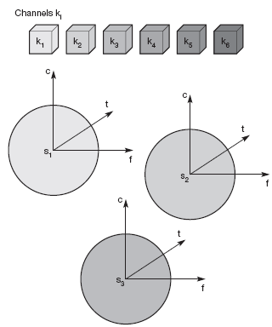

Space Division Multiplexing

- Frequency Division Multiplexing

The oldest used technique used for multiplexing. Possible when the useful bandwidth of the medium exceeds that of the signals it has to carry. Each signal is modulated on a different carrier frequency. This results in shifting the spectrum of the signal around the carrier frequency. Sufficient guard-band is given so those neighboring signals do not overlap in the frequency domain.

At the receiving end each signal is extracted by first passing it through a band-pass filter and then demodulating with the same carrier frequency that was used to modulate the signal. The signals carried using FDM may be analog signals or may be analog signals representing digital data. However FDM is mostly a technique from the era of analog communications. In FDM a device uses some of the channel all of the time. FDM is used in radio and television broadcasting. FDM is also used in high capacity long distance links in the telephone network.
Frequency division multiplexing (FDM) achieves multiplexing by using different carrier frequencies .Receiver can "tune" to specific frequency and extract modulation for that one channel .Frequencies must be separated to avoid interference - “Wastes” potential signal bandwidth for guard channels.Only useful in media that can carry multiple signals with different frequencies - high-bandwidth required .

FDM is used as follows,
- The standard of the analog telephone network
- The standard in radio broadcasting
- The standard for video
  - Broadcast
  - Cable
  - Satellite
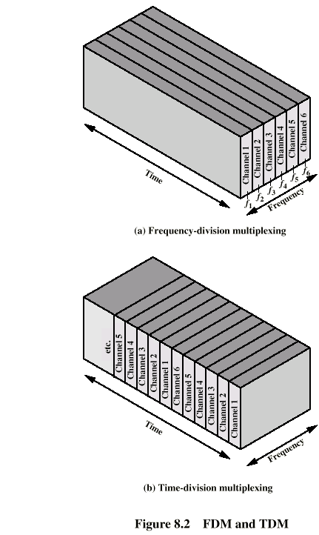
Frequency Division Multiplexing Diagram

This method subdivides the frequency into many non-overlapping frequency bands. Each channel is allotted to an own frequency band. Guard spaces are needed to avoid overlapping. This overlapping is called adjacent channel interference. (e.g.) Radio stations.

Advantages:
    - Simple mechanism.
    - No need of co-ordination.

Disadvantages:
- Wastage of channel as the mobile device will be used for few minutes
- Frequency resource is scarce.
- Limits the number of senders and is in inflexible

3.Time Division Multiplexing

Time division multiplexing is more suitable for digital data. TDM can be used when the data rate available on a communication link exceeds the data rate required by any one of the sources. In TDM each source that is to use the link fills up a buffer with data. A TDM multiplexer scans the buffers in some predetermined order and transmits bits from each source one after the other.

- Requires digital signaling & transmission
- Requires data rate = sum of inputs + framing
- Data rate much higher than equivalent analog bandwidth uses
- Separates data streams in time not frequency
- The standard of the modern digital telephone system

Time Division Multiplexing

Here the time is shared which is more flexible. The channel is given the whole bandwidth for a certain amount of time. Guard spaces separate the different time periods. When the two transmissions overlap in time this is called as co-channels interference. Synchronization between the senders is needed. FDM and TDM can be combined and used in GSM.

Advantages:

- Flexible
- Time can be adjusted based upon the load.

Disadvantage:

- Synchronization needed.

4.Code division Multiplexing

Each channel has a unique code. All channels use the same spectrum at the same time.

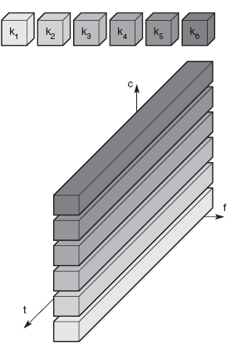

Code division Multiplexing
This is a new scheme in communication. All the channels use the same frequency at the same time for transmission via a code. Separation is needed and done by the own code called guard spaces. Analogy can be had as in a party people taking in their own language which is unknown to many. The language is the code here.

Advantages:

- Protection against interference and tapping.
- Code space is huge.

Disadvantages:

- High complexity at the receiver.
- The receiver needs to know the code and should separate the data from the noise.
- The receiver must be synchronized with the sender.
- Power control is needed.

8. Modulation

The process of transmitting the baseband signal, which may be varied accordance with the data or carrier frequency is called modulation.
The wireless transmission needs analog modulation. The function of analog modulation is to shift the center frequency of the baseband signal generated by the digital modulation up to the radio carrier. The analog modulation is needed because baseband signals cannot be directly transmitted via wireless systems due to,

i)Antenna:
The height of the antenna depends upon magnitude of the signals wavelength for 1 MHz signal the antenna height should e 100 m.

ii)Frequency Division Multiplexing:
For base band transmission FDM cannot be used. The higher the carrier frequency the more bandwidth is available for base band signals.

iii)Medium Characteristics:
  - Path loss, Reflection, Refraction etc.depends upon the wavelength of the signal.
  - The carrier frequency needs to be chosen based upon the application.

Methods for Analog Modulation
As for digital modulation, three different basic schemes are known for analog modulation:
1. Amplitude modulation (AM),
2. Frequency modulation (FM),
3. Phase modulation (PM).

Procedure for Modulation in Transmitter and Receiver

Following Figure shows a (simplified) block diagram of a radio transmitter for digital data. The first step is the digital modulation of data into the analog baseband signal according to one of the schemes presented in the following sections. The analog modulation then shifts the center frequency of the analog signal up to the radio carrier. This signal is then transmitted via the antenna.
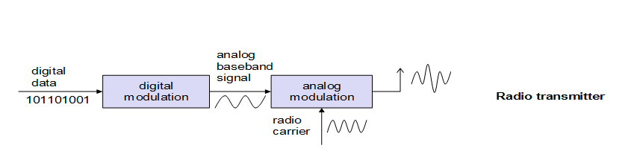

Radio Transmitter

The receiver receives the analog radio signal via its antenna and demodulates the signal into the analog baseband signal with the help of the known carrier. This would be all that is needed for an analog radio tuned in to a radio station. (The analog baseband signal would constitute the music.) For digital data, another step is needed. Bits or frames have to be detected, i.e., the receiver must synchronize with the sender. The synchronization is achieved by depending upon the digital modulation scheme. After synchronization, the receiver has to decide if the signal represents a digital 1 or a 0, reconstructing the original data.
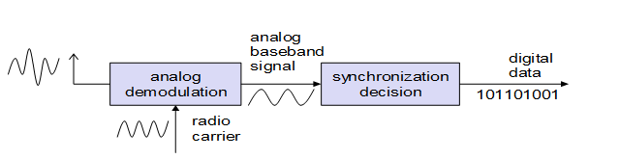
Radio Receiver

Finally the receiver has to decide if the signal represents 1 or 0. Modulation of digital signals is known as Shift Keying.

Problems faced by digital modulation
- Spectral Efficiency
- Power Efficiency
- Robustness

Method of the conversion of digital data into analog base band signals

- Amplitude shift keying
- Frequency shift keying
- Phase shift keying

Amplitude shift keying

- Simplest digital modulation scheme. The binary values 1 and 0 are represented by two different amplitudes.
- Requires low bandwidth, susceptible to interferences
- In wireless constant amplitude cannot be guaranteed hence unfit for wireless.
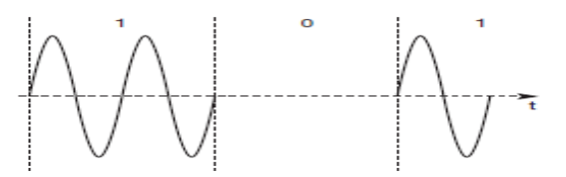
Amplitude shift keying (ASK)

Frequency shift keying

- This scheme is used with wireless transmission.Simplest form of FSK is binary FSK.
- Assign one frequency f1 to 1 and another frequency f2 to 0.
- To implement is to switch between 2 oscillators. To avoid sudden changes special frequency modulation with continuous phase modulation.
- FSK needs a larger bandwidth.
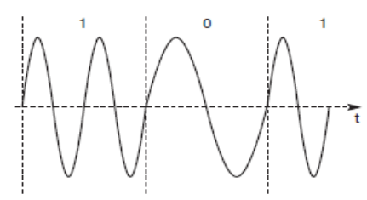
Frequency shift keying (FSK)

Phase shift keying

- This scheme uses shifts in the phase of a signal to represent data.
- The figure represents a phase shift of 180⁰
- This is called as binary PSK because shifts y 280⁰ for change in bit.
- To receive the signal the receiver must synchronize frequency and phase with the transmitter.
- The synchronization can be done with phase lock loop(PLL)
- PSK is more resistance to interference
  - Transmitter and receiver are more complex.

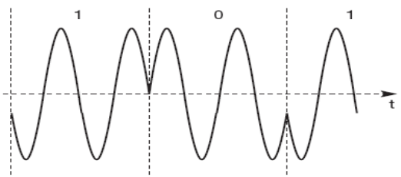
Phase shift keying (PSK)
9.Spread spectrum

As the name implies, spread spectrum techniques involve spreading the bandwidth needed to transmit data – which does not make sense at first sight. Spreading the bandwidth has several advantages. The main advantage is the resistance to narrowband interference. The following figure,
i) Shows an idealized narrowband signal from a sender of user data (here power density dP/df versus frequency f). The sender now spreads the signal. In step ii) Converts the narrowband signal into a broadband signal. The energy needed to transmit the signal (the area shown in the diagram) is the same, but it is now spread over a larger frequency range. The power level of the spread signal can be much lower than that of the original narrowband signal without losing data. Depending on the generation and reception of the spread signal, the power level of the user signal can even be as low as the background noise. This makes it difficult to distinguish
the user signal from the background noise and thus hard to detect.
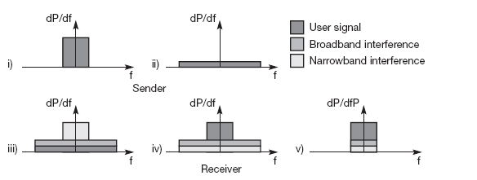
Effects of spreading and interference

During transmission, narrowband and broadband interference add to the signal in step iii). The sum of interference and user signal is received. The receiver now knows how to dispread the signal, converting the spread user signal into a narrowband signal again, while spreading the narrowband interference and leaving the broadband interference. In step v) the receiver applies a
bandpass filter to cut off frequencies left and right of the narrowband signal. Finally, the receiver can reconstruct the original data because the power level of the user signal is high enough, i.e., the signal is much stronger than the remaining interference.

9.1 Direct Sequence Spread Spectrum (DSSS)

Direct sequence spread spectrum (DSSS) systems take a user bit stream and perform an (XOR) with a so-called chipping sequence as shown in figure. The example shows that the result is either the sequence 0110101. While each user bit has a duration t_{b}, the chipping sequence consists of smaller pulses, called chips, with a duration t_{c}. If the chipping sequence is generated properly it appears as random noise: this sequence is also sometimes called pseudo-noise sequence. The spreading factor s = t_{b}/t_{c} determines the bandwidth of the resulting signal. If the original signal needs a bandwidth w, the resulting signal needs s·w after spreading. The civil applications use spreading factors between 10 and 100, military applications use factors of up to
10,000. Barker codes are used as chipping sequence. It exhibit a good robustness against interference and insensitivity to multi-path propagation.
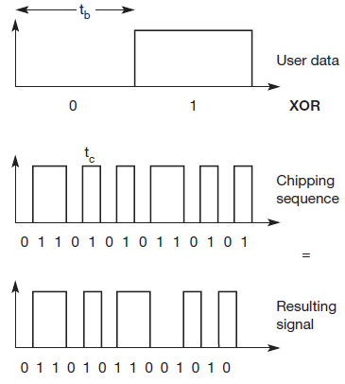

Direct Sequence Spread Spectrum Transmitter

The first step in a DSSS transmitter is the spreading of the user data with the chipping sequence (digital modulation). The spread signal is then modulated with a radio carrier. This signal is then transmitted.
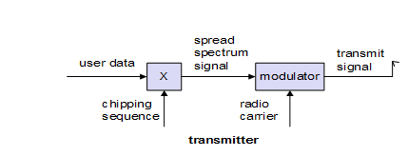
DSSS Transmitter

DSSS Receiver

The DSSS receiver is more complex than the transmitter. The receiver only has to perform the inverse functions of the two transmitter modulation steps. However, noise and multi-path propagation require additional mechanisms to reconstruct the original data. The first step in the receiver involves demodulating the received signal. This is achieved using the same carrier as the transmitter reversing the modulation and results in a signal with approximately the same bandwidth as the original spread spectrum signal. Additional filtering can be applied to generate this signal. While demodulation is well known from ordinary radio receivers, the next steps constitute a real challenge for DSSS receivers, contributing to the complexity of the system.
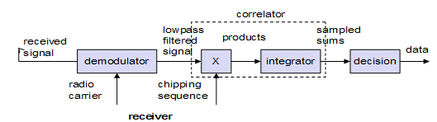
DSSS receiver

The receiver has to know the original chipping sequence, i.e., the receiver basically generates the same pseudo random sequence as the transmitter. Sequences at the sender and receiver have to be precisely synchronized because the receiver calculates the product of a chip with the incoming signal. During a bit period, which also has to be derived via synchronization, an integrator adds all these products. Calculating the products of chips and signal, and adding the product in an integrator is also called correlation, the device used here is a correlator. Finally, in each bit period a decision unit samples the sums generated by the integrator and decides if this sum represents a binary 1 or a 0. If transmitter and receiver are perfectly synchronized and the signal is not too distorted by noise or multi-path propagation, DSSS works perfectly well according to the simple scheme shown. Sending the user data 01 and applying the 11-chip Barker code 10110111000 results in the spread ‘signal’ 1011011100001001000111. On the receiver side, this ‘signal’ is XORed bit-wise after demodulation with the same Barker code as chipping sequence.

9.2 FHSS (Frequency Hopping Spread Spectrum)

For frequency hopping spread spectrum (FHSS) systems, the total available bandwidth is split into many channels of smaller bandwidth plus guard spaces between the channels. Transmitter and receiver stay on one of these channels for a certain time and then hop to another channel. This system implements FDM and TDM. The pattern of channel usage is called the hopping sequence, the time spend on a channel with a certain frequency is called the dwell time.
FHSS comes in two variants, slow and fast hopping

Following figure shows five user bits with a bit period t_{b}. Performing slow hopping, the transmitter uses the frequency f₂ for transmitting the first three bits during the dwell time t_{d}. Then, the transmitter hops to the next frequency f₃. Slow hopping systems are typically cheaper and have relaxed tolerances, but they are not as immune to narrowband interference as fast hopping systems. Slow frequency hopping is an option for GSM. For fast hopping systems, the transmitter changes the frequency several times during the transmission of a single bit. In the following example , the transmitter hops three times during a bit period. Fast hopping systems are more complex to implement because the transmitter and receiver have to stay synchronized within smaller tolerances to perform hopping at more or less the same points in time. However, these systems are much better at overcoming the effects of narrowband interference and frequency selective fading as they only stick to one frequency for a very short time. Another example of an FHSS system is Bluetooth, which is presented in section 7.5. Bluetooth performs 1,600 hops per second and uses 79 hop carriers equally spaced with 1 MHz in the 2.4 GHz ISM band.
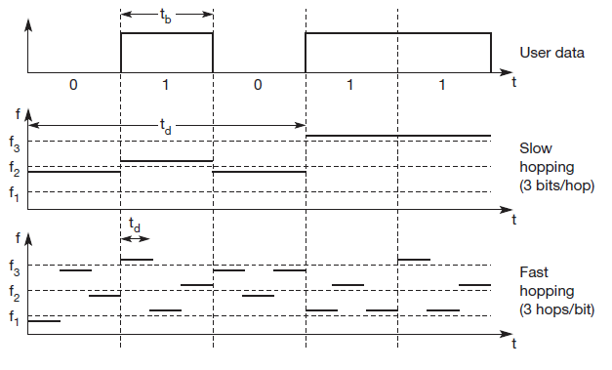

The first step in an FHSS transmitter is the modulation of user data according to one of the digital-to-analog modulation schemes, e.g., FSK . This results in a narrowband signal. In the next step, frequency hopping is performed, based on a hopping sequence. The hopping sequence is fed into a frequency synthesizer generating the carrier frequencies. A second modulation uses the modulated narrowband signal and the carrier frequency to generate a new spread signal. If different FHSS transmitters use hopping sequences that never overlap, i.e., if two transmitters never use the same frequency at the same time, then these two transmissions do not interfere. This requires the coordination of all transmitters and their hopping sequences.

As for DSSS systems, pseudo-random hopping sequences can also be used without coordination. These sequences only have to fulfill certain properties to keep interference minimal. Two or more transmitters may choose the same frequency for a hop, but dwell time is short for fast hopping systems, so interference is minimal.
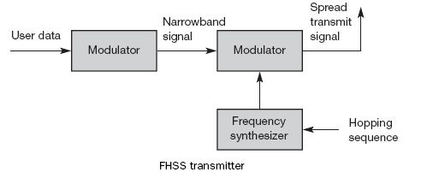
The receiver of an FHSS system has to know the hopping sequence and must stay synchronized. It then performs the inverse operations of the modulation to reconstruct user data. Several filters are also needed. Compared to DSSS, spreading are simpler using FHSS systems. FHSS systems only use a portion of the total band at any time, while DSSS systems always use the total bandwidth available.
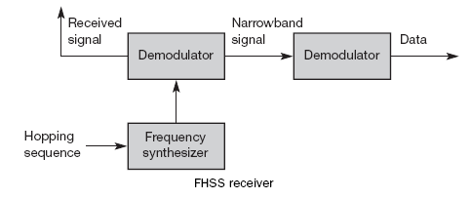

DSSS systems on the other hand are more resistant to fading and multi-path effects. DSSS signals are much harder to detect – without knowing the spreading code, detection is virtually impossible. If each sender has its own pseudo-random number sequence for spreading the signal (DSSS or FHSS), the system implements CDM

10. Medium Access Control (MAC)

Overview:

MAC comprises all the mechanisms that regulate user access to medium using SDM, TDM, FDM, and CDM. Special MAC is needed in wireless because of hidden and exposed terminals or near and far terminals. One scheme is not purely used in a system but mix of schemes is used in reality.

The need of Special MAC:

Let us consider the wired CSMA/CD scheme,
  - A sender senses the medium to see if it is free. If the medium is busy the sender waits until the medium is free. If found free then, starts transmitting the data and continues to listen the medium. If the sender detects any collision, it stops transmission immediately and sends jamming sequence.
  - This scheme does not work in wireless. Because CSMA/CD does not consider the collisions in the sender side. It consider only at the receiver end.
  - This is not a problem with wired because the same signal strength is assumed to be present all over the wire.If collisions occur in the wire, it can be noticed by all.

Problem when used in wireless

This will not work in the wireless because signal strength decreases to the square of the distance of the sender. The sender senses the medium and finds it to be free, the sender starts sending the message but a collision occurs at the receiver due to second sender. This problem is called as hidden terminal problem.
If the sender, does not detect any collision and assumes that the data has been transmitted without errors. But, collision might have occurred. Collision detection is very difficult in wireless. So wired MAC cannot be used for wireless.
More details on why MAC of fired networks fail in wireless scenario

The fixed MAC when used on wireless faces the following scenario,

(1) Hidden and exposed terminals,
(2) Near and far terminals.

1.Hidden and Exposed Terminals

Hidden Terminal

Consider 3 mobile phases as shown below,
  - The transmission range of ‘A’ reaches ‘B’ but not ‘C’.
  - The transmission range of ‘C’ reaches ‘B’ but not ‘A’.
  - Transmission range of ‘B’ reaches ’A’ and ‘C’.
  - ‘A’ starts sending to ‘B’,’C’ does not receive this transmission.
  - ‘C’ also wants to send to ‘B’ ,and senses the medium is free ‘C’ also starts sending message to ‘B’ hence resulting in a collision at ‘B’.
  - ‘A’ cannot detect the collision at ‘B’ and still continues to send message.
  - ‘A’ is hidden for ‘C’.
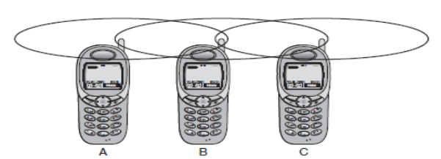
Hidden and Exposed Terminals

Exposed Terminal

- Consider the scenario that ‘B’ to sends a message to A, ‘C’ wants to send a message to some other mobile which is outside the reference of A and B.
- ‘C’ senses that the medium is busy hence it postpones the transmission until it detects the medium is idle. In this scenario ‘C’s waiting is unneeded.
- Causing a collision at ‘B’ does not matter because the collision in too weak to propagates to A, C is exposed to B.

2.Near and Far Terminals

- ‘A’ and ‘B’ are sending with same transmission power to ‘C’.
- The signal strength decreases to the square of the distance.
- Due to the above ‘b’s signal drowns out ‘A’s signal as result ‘c’ cannot receive A’s information.

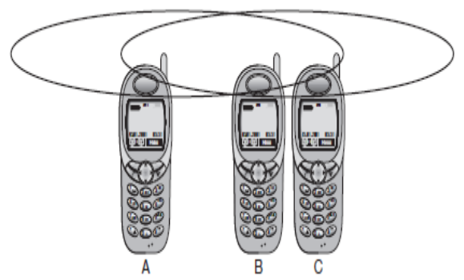

Near and Far Terminals

- The near/far effect is a severe problem of a wireless using CDM.
- All signals should arrive at the receiver with the almost same strength.
- If not the one’s which is closer will have higher strength than the one which is farther away.
- So if separated by code, the closest one would drown the others.

Mechanisms to access the medium

The following are the mechanisms used to access the medium,
- SDMA
- FDMA
- TDMA
- CDMA

10.1 SDMA

- SDMA stands for Space division Multiple Access.
- SDMA is used for allocating separated space to users of wireless network.
- Application is assigning an optimal base station to a mobile phone.
- MAC algorithm decides which base station is best taking into consideration, TDM, CDM.
- SDMA is never used in isolation but used with one or more schemes.
- The SDMA algorithm works on cells and sectorized antenna which form the infrastructure.

10.2 FDMA

- FDMA stands for frequency division multiple accesses.
- Contain algorithm allocating frequencies to transmission channels according to FDM,
- Allocation can be fixed or dynamic.
- Channels can be assigned to the write Fixed /Dynamic frequency at tall times(i.e.) Pure FDMA or FDMA with TDMA is the fixed allocation. The vice versa is dynamic
- Sender and receiver need to agree on a hoping pattern otherwise receive could not tune to the right frequency.
- Hopping patters are fixed at least for a longer period.
- FDM is used for simultaneous access to the medium by base station and mobile station cellular networks.
- The two partners establish a duplex channel (i.e.) a channel that allows transmission in both directions. The two directions, mobile station to base station and vice versa are separated using different frequencies. This scheme is called frequency division duplex.
- The both partners need to have to know the frequencies in advance.
- The two frequencies are also known as uplink and downlink.
- The uplink is from mobile station to base station or ground control to satellite
- The downlink is from base station to mobile station or from satellite to ground control.
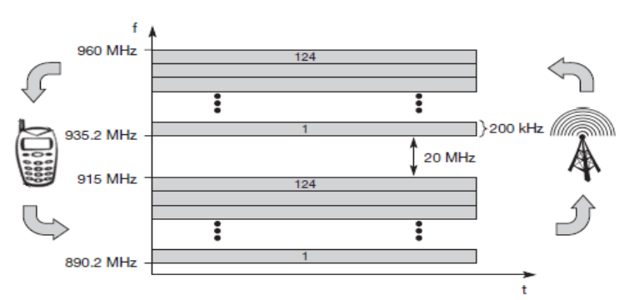
Frequency Division Multiplexing for Multiple Access and Duplex (FDMA)

10.3 TDMA

- TDMA stands for time division multiple access.
- TDMA offers flexible scheme, allocates time slots for communication which is controlled by TDM. The receiver need not tune the frequency. They can stay at the same frequency.
- Uses only one frequency, many algorithms exist to control the medium access
- Here the system listens to many channels separated in time at the same frequency
- Synchronization between the sender and receiver needs to be achieved.
- To do the synchronization the channel is allocated a fixed time slot (or) by using dynamic allocation scheme.

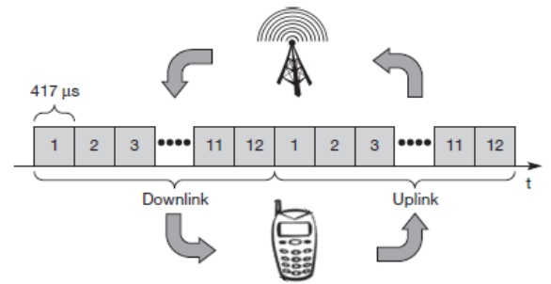
Time Division Multiplexing for Multiple Access and Duplex

- For dynamic allocation identification of each transmission is necessary.
- MAC address is used as identification. This Identification makes the receiver identify when any message is intended for it.Fixed schemes do not need an identifications, but inflexible.

Types of TDM

(a) Fixed TDMA
  - Demand Oriented TDMA

a)Fixed TDM

- This is the simplest algorithm for using TDM. Here time slots are allocated for channels in the fixed pattern. Hence the result is fixed bandwidth. Now external synchronization needed.
- Each mobile must know its turn, hence no inference will occur. The pattern is to be assigned by the base stations.
- This environment suits well,
      - When the bandwidth is fixed.
      - When the system needs fixed delay.
      - Constant data rate.
- The frequency is same.
- Assigning the different slots for uplink and downlink with the same frequency is called as Time Division Multiplex.

Advantages:

- Bandwidth is fixed
- Delay is fixed
- Constant data rate

Disadvantages:

- Wastage of bandwidth when the system has no data to transmit
- Inflexible
- Not suitable for burst data

b)Demand oriented TDMA

The demand oriented TDMA methods are,

- Classical Aloha
- Slotted Aloha
- CSMA
- DAMA
- PRMA
- Reservation TDMA
- MACA
- Polling
- ISMA

1.Classical Aloha

- Here the TDMA is applied without controlling the access. Each station can access the medium without a central arbiter controlling the access and without co-ordination.
- If two or more stations access the medium at the same time collision occurs and the data transmitted is too destroyed. ALOHANET is used for wireless connection of several stations. Aloha is neither co-coordinated nor resolves contention. Can be used under light load.

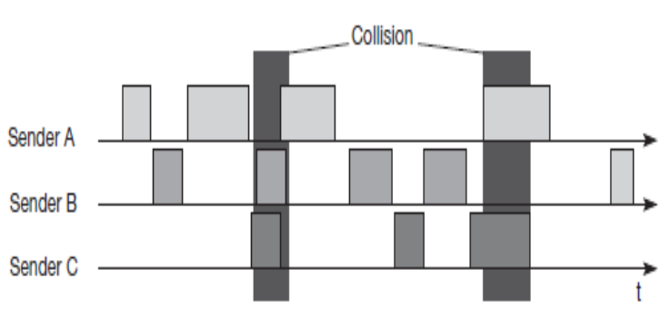
Classical Aloha

2. Slotted Aloha

- In slotted Aloha the time is divided into slots. All the senders need to be synchronized.
- When the sender wants to transmit attempts at the beginning of time slot.
- Synchronization is done at the beginning of the of time slot.
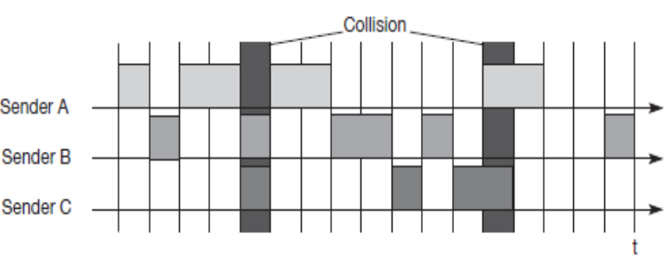
Slotted Aloha Multiple Access

- Systems are not co-ordinate. Through put is doubled from classical Aloha to slotted Aloha. Well suited for light load.
- Guarantees for maximum delay and throughput in not given.

3.CSMA

- Carrier senses multiple accesses.
- The medium is sensed before the access. Hence the name CSMA/
- The concept of sensing and accessing the medium decreases the probability of collision. Hidden terminals cannot be detected. Hence collision can occur at the receiver.

Types of CSMA.

(i) Non-Persistent CSMA:
- Station sense the medium and start sending immediately if the medium is free.
- If the medium is busy the stations waits for a random amount of time and the once again senses the medium. Repeats the above if the medium is found busy.

(ii) P-Persistent CSMA:
- The node senses the medium.
- Transmit with a probability P, when the medium is free and postponing to the next slot with the probability 1-P.

(iii) 1-Persistent CSMA:
- All the nodes wishing to transmit data, senses the medium and transmits the data as soon as the medium is idle with probability
- Results in collision if many want to transmit data.
- This method is unfair; hence to introduce fairness the stations waiting for a longer time will be given the chance.

(iv) CSMA/CA (Collision Avoidance):
The medium is sensed and if found busy waiting time follows the back off scheme. Thus
avoids the occurrence of collision.

4.DAMA

Demand Assigned Multiple Access (or) Reservation Aloha

- This method uses the concept of Reservation and Fixed TDMA. Here there is a fixed reservation period followed and fixed TDMA.
- During the reservation periods the stations can reserve future slots in the transmission period. Collisions can occur during the reservation period only.
- This method has two phases.
  - Contention phase
  - Transmission phase.

Contention Phase:

This is the reservation phase
- This phase follows the slotted aloha scheme. During this phase all the stations reverse the future slot. Collision occurs during this phase.
- If successful time slot for the future is reserved no other station is allowed to transmit during this slot. The stations need to be synchronized. This is an explicit reservation scheme.

Transmission Phase:

The reserved senders transmit the data during this phase.
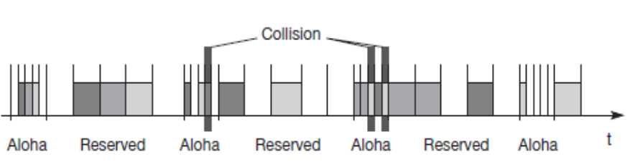
Transmission Phase

5. Packet Reservation Multiple Access (PRMA)

  - PRMA is an implicit reservation scheme.The slots are reserved according to the scheme described below.

Scheme:

- Frame is divided into slots. The frame is repeated in time with fixed TDM.
- The base station broadcasts the status of each slot to the mobile stations.
- All the stations receive this broadcast and determine which slot is free and which slot is occupied. The station’s name is indicated in the slot which is reserved for that station.
- For example of frame 1 it reads as ACDABA-F. this indicates that the 7th slot is free
- The stations wanting the slot compete in an Aloha scheme.
- If more stations compete collision occurs then the base stati8on returns the reservation status of frame 1 as ACDABA-F.
- Again the stations can compete for the 7th slot.

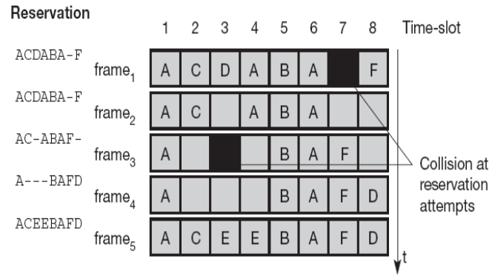
Packet Reservation Multiple Access

6.Reservation TDMA

- This method allows randomness and freedom. The frame has reservation phase followed y transmission phase. The reservation has fixed TDM scheme of N mini slots.
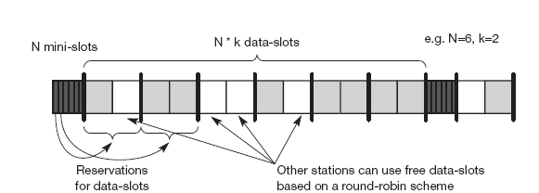

Reservation TDMA access scheme

- The transmission phase has N.K data slots for the frame where K is the data slot for 1 mini slot. Guarantees bandwidth and fixed delay. Other stations can send in unused slots only. The free slots usage can be via round robin or aloha.

7.Multiple Access with Collision Avoidance (MACA)

- The previous access mechanisms do not handle the problem of hidden terminal.
- MACA has a simple scheme which solves a hidden terminal problem does not need a base station. Follows random access, with dynamic reservation.

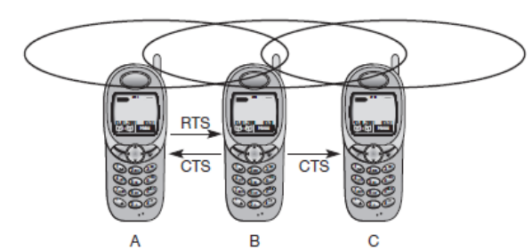
MACA can avoid hidden terminals

- The sender ‘A’ sends a RTS (Request to send) signal to the receiver ‘B’.
- The RTS contains the name of the sender, receiver and duration of transmission.
- RTS is not heard by ‘C’. But triggers an acknowledgement from ‘B’, called CTS (clear to send) signal to ‘A’.
- The CTS again contains the names of sender (A) and receiver (B) of the user data,
and the length of the future transmission.
- CTS is heard by ‘A’ and ’C’ discards. Because it is neither the sender nor the receiver.
- This CTS indicates that ‘B’ is involved in transmission and hence ’C’ cannot send any message to ‘B’. Hence collision is avoided at ‘B’ thus solving the hidden terminal problem. When ‘A’ and ‘C’ sends RTS at the same time to ‘B’. Collision occurs there. RTS is very small compared to the data transmission, so the probability of a collision is much lower. ‘B’ resolve the contention by sending acknowledgement CTS to one station.

Exposed Node Problem Solution:

- ‘B’ sends RTS to ‘A’
- ‘C’ does not react to this message
- ‘A’ acknowledges and sends CTS to ‘B’.
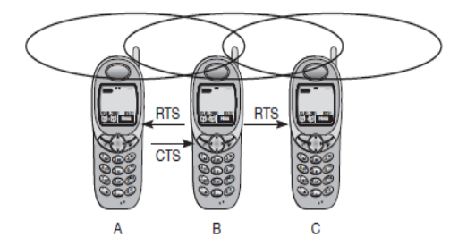
MACA can avoid exposed terminals

- CTS from ‘A’ to ‘B’ are not heard by ‘C’.
- Hence ‘C’ can start transmission to a different uses, thus avoiding exposed node problem.

Problem faced:

- Overheads in sending RTS and CTS.
- Unsuitable for time critical data packets which is to be transmitted in short duration
- State diagram for the sender and receiver.

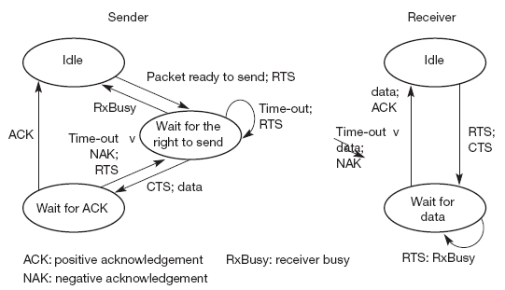

Sender

- The sender is on the idle state until a user requests for transmission of data. The sender issues an RTS and waits for CTS. If the receiver gets the RTS and if free sends CTS and waits for data. The sender receiver CTS and sends data.
- If the sender didn’t receive CTS, the sender world sends RTS after time out.
- If it has received sends the data and waits for acknowledgement and returns to waiting state. If the receiver sends positive acknowledgement the sender and receiver moves to idle state.
- If the sender receives a negative acknowledgement the sends RTS once again. The receiver can indicate that it is busy via R_{x} busy message.

8.Polling

- This scheme is a centralized scheme. In this scheme there is one master and many slave stations. The master polls the slaves according to any one of the schemes like that of round robin.
- There is contention phase and transmission phase. In the contention phase the master can poll the slaves to reserve the transmission phase
- The transmission is done according to the reservation.

9.ISMA-Inhibit Sense Multiple Access

- The medium is detected by inhibition. The base station signals a medium busy via busy tone on the down link. When the medium is free the busy tone stops. The uplink is not co-ordinated.
- The base station acknowledges is the successful transmission.In case, when the acknowledge is missed the mobile devices can conclude a collision.

10.4 CDMA

- CDMA stands for code division multiple accesses. CDMA uses the technique of code division multiplexing. CDMA uses the codes to separate the users in code space thus helping the medium to be shared without interference.

Spread Aloha multiple Access:

Here the CDMA and Aloha are combined to from SAMA.Users use the same spreading code. Sender A and B access the medium at the same time in their narrow band spectrum resulting in collision. The same data can be sent with higher power for shorter period 1 the spread spectrum is used to spread the signal to increase the bandwidth.

Advantages:

- Collision is low.
- Spread spectrum a result in robustness against narrow band interference.
- Coexistence with other systems n same frequency band.

Disadvantages:

- Finding the good chipping sequence is difficult.
- Code is not orthogonal to itself.
Comparison of the medium access mechanism

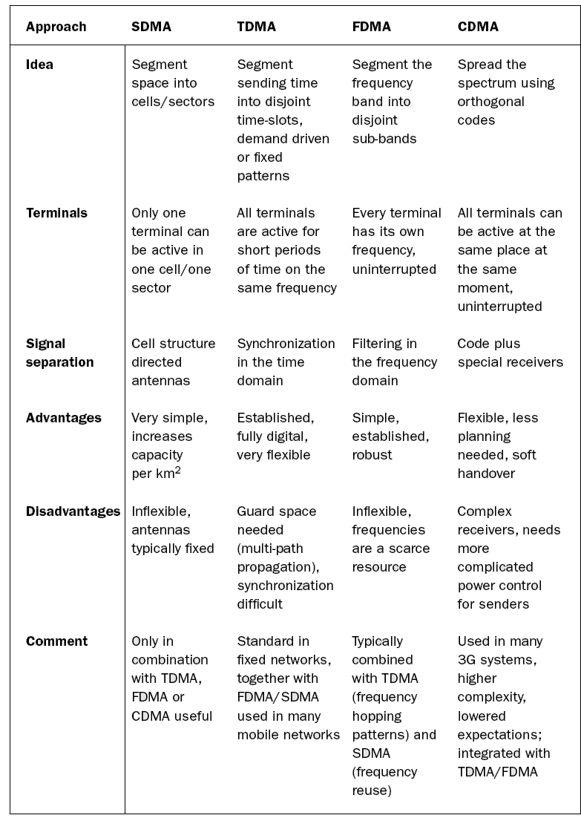
11.Introduction to cellular system

General Concept

The following concept holds when cell system follows SDM. For mobile communication, transmitter is needed. The transmitter is called as base station. The base station covers certain area called cell. The radius of the cell can be from meters, tens of meters, kilometers. The shape of the cells is assumed to be circle or hexagon. The real shape depends upon environment, weather and load. Because of this reason of coverage there are thousands of base stations throughout. The drawback is in eh interference. Hence never use the same frequency at the same time within the Interference Range.

Cell : Why Hexagon?

- In reality the cell is an irregular shaped circle, for design convenience and as a first order approximation, it is assumed to be regular polygons
- The hexagon is used for two reasons:
  - A hexagonal layout requires fewer cells, therefore, fewer transmission site
  - Less expensive compared to square and triangular cells
- Irregular cell shape leads to inefficient use of the spectrum because of inability to reuse frequency on account of co channel interference uneconomical deployment of equipment, requiring relocation from one cell site to another.

Advantages of cell structures

- Higher capacity, higher number of users
- Less transmission power needed
- More robust, decentralized
- Base station deals with interference, transmission area etc. locally

Problems

  - Fixed network needed for the base stations.
  - Handover (changing from one cell to another) necessary.
  - Interference with other cells.
  - Cell sizes from some 100 m in cities to, e.g., 35 km on the country side (GSM) - even less for higher frequencies.

11.1 Methods to create cell patterns

Clusters: Cells are combined to form clusters.

Types:

- Three cell forming a cluster.
- Seven cells forming a cluster.
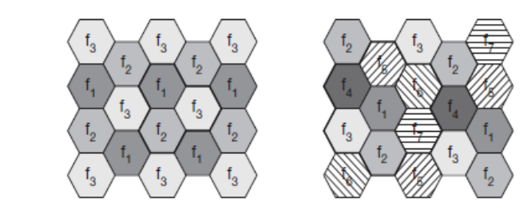

Three cells forming a cluster

All the cells within a cluster use a different set of frequencies. Moreover still l to avoid interference sectorized antenna can be used.

Assignment of frequency to cells

1. Fixed
2. Dynamic

1.Fixed: Here the frequencies are assigned in advance to the cell cluster and cell respectively. This method is called as Fixed Channel Allocation (FCA) used in GSM.

Disadvantage: Not efficient in different traffic load condition.

2.Dynamic: Here the frequency can be borrowed and the frequency can be freely assigned to cells used in DECT. It is called as Dynamic Channel Allocation (DCA).
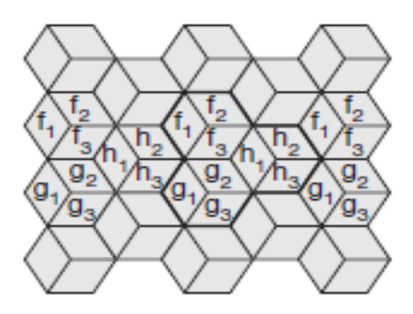
Cells using sectorized antenna

As the frequencies are repeated, the transmission power has to be limited to avoid interference. Another method to reduce the interference it’s to use sectorized antenna.

Borrow of Frequency

Here when a cell has heavy traffic and its neighbor has light load, the frequency can be borrowed. This scheme is called as Borrowing Channel Allocation (BCA).

Breathe:

Cellular systems using CDM instead of FDM do not need such elaborate channel allocation schemes and complex frequency planning. Here, users are separated through the code they use, not through the frequency. Cell planning faces another problem. The cell size depends on the current load. Accordingly, CDM cells are commonly said to ‘breathe’. While a cell can cover a larger area under a light load, it shrinks if the load increases. The reason for this is the growing noise level if more users are in a cell.

Advantages of Cellular System with Small Cells

(1) Higher Capacity:
- With SDM the frequency can be reused.
- Frequency reuse is feasible if the two transmitters are far away.
- Small cells allow more users.

(2) Less Transmission Power:
- Power is problematic for the mobile/hand held devices.
- The devices which are closer to the base station needs less transmission power.

(3) Local Interference:
- In small cells the mobile and base station need to cater only the local interference.
- In this case of large cells they have to cater more interference problems.

(4) Robustness:
- Cellular systems are decentralized.
- If one antenna fails it affects only small area.

Disadvantages:

(1) Infrastructure:
- Cellular systems need complex infrastructure to connect all base stations.
- (e.g.) Antenna, Location registers, switches are needed, which makes the
system costly.

(2) Handover:
- As the cell size is small more number of handover is needed.
- Handover means, when quality is low, the mobile needs to be handed over from
one transmitter to another.

(3) Frequency:
- As the frequency is reused between transmitters, to avoid the interference the frequency has to be distributed carefully.
- More over only limited number of frequencies are available.

Important Questions:
2 Marks:

1. List out the applications of wireless networks and mobile communication.
2. Why do we use antenna? Mention its types.
3. How the spreading factor is calculated in spread spectrum?
4. What is polling?
5. Define line of sight and delay spread.
6. What is multiplexing? List the different types of multiplexing.
7. Define CSMA/CD.
8. Mention the advantages and disadvantages of cellular systems.
9. Draw a neat diagram for modulation in a transmitter and in a receiver.
10. What are the different types of propagation behavior exhibit in radio waves?

16Marks:

- Describe the steps involved in Direct Sequence and Frequency hopping spread spectrum with neat diagrams. (16)
- (i) Discuss in detail about the types of antennas with their radiation patterns.(8)
(ii) Write a detailed note on cellular systems. (8)
- Briefly discuss about multiplexing techniques. (16)
4. (i) What is Modulation? Explain about analog and digital modulation schemes. (10)
(ii) Compare SDMA, TDMA, FDMA and CDMA. (6)
5. (i)Why do MAC schemes in wired networks fail in wireless networks? (8)
(ii) How does the multiple access with collision avoidance (MACA) scheme work? (8)
6. Discuss in detail about Signal Propagation. (16)

